
Dualsky Linear Brake Mode Instructions

Linear brake mode is an original ESC brake technology created by Dualsky. It can fine adjust the brake force of brushless motor in the range of non-powered, thus to control the speed of diving down or landing. Different from the brake function of other ESCs, DLBM has the following advantages:
- Motor brake force can be adjusted. • The adjusting accuracy is 1%• • Adjust easily by Transmitter.

a Applicable ESC
Dualsky Xcontroller V2 is equipped with this function.
While V1 does not has this function.

fl Open up the function of DLBM.
Method 1: Set the DLBM ON by ProgCARD-V2(#45200).
Method 2: Connect the USB LINK(#45525) to PC, using the V2 Software to set DLBM ON.
Method 3: Use the Transmitter throttle programming to set DLBM/Brake ON, via prompt tone.
(Details refer to ESC Manual).

El Use DLBM to control flying.
After opening DLBM function, user can feel the power system brakes obviously when the Transmitter throttle lever is at the bottom. At this point the throttle signal is divided into two areas:

- Simple settings: By setting the value in the bottom of the End Point of Throttle Channel can reduce the brake force. For example, set the End Point to be go%, corresponding brake force will be 50%. (Prerequisite: Throttle range of ESC and throttle range of Transmitter should have been matched. Details refer to ESC Manual.)
- Advanced Settings: Setting through the Point Throttle Curve is more delicate.
  - Accurately set the throttle position for power outputting. (Point A)
  - Accurately set the brake force when throttle is at the lowest position. (Point B) It can also add some throttle EXP. to fine control the senior models.

PointA -

PointB -

Throttle: 21% -100%
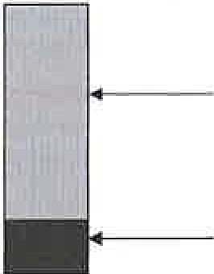
Corresponding power: 1% - 100%

Throttle: 20% - 1%
Corresponding brake force: 1% - 100%

Dualsky Governor Mode Instructions
IIThe Governor default mode is OFF. Before you start using Governor Mode please check the settings of the throttle curve to avoid any risks.

Note: Governor Mode should be controlled on your transmitter with a switch or as a Flight Mode. The throttle output will be normal in the default mode.
II You can set the Governor mode to ON (in Dualsky V2 ESC's 40A or up) when programming by the throttle or with a ProgCARD or USB LINK . The Governor Mode is used to maintain constant head speed (motor RPM) irrespective of the load on the motor (pitch setting).
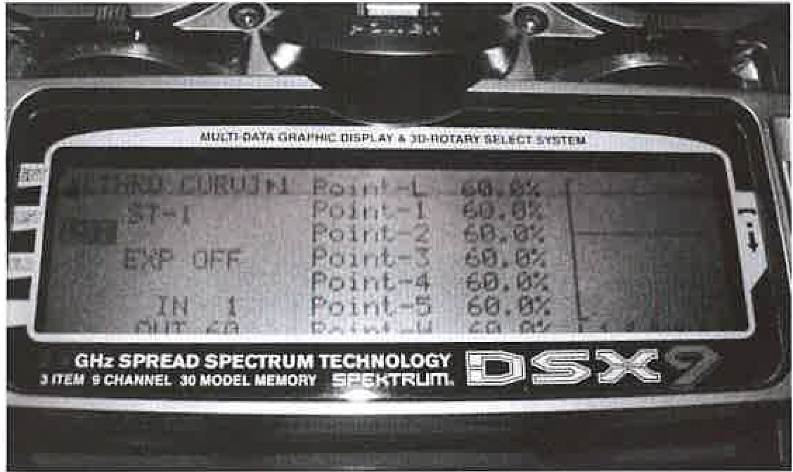
II By setting the throttle curve for a Flight Mode in your transmitter, you can make the throttle (head speed) constant at a desired RPM.
For example:

Point 1: 60%
Point 4: 60%
Point 2: 60%
Point 5: 60%
Point 3: 60%

II Please be sure to test your settings before attempting to fly the model. When governor mode is activated, the motor will run at a fixed RPM, no matter what changes you make to the throttle stick. Only the pitch will change.
If you feel the RPM of the main roiors (head speed) is too low, you can change your throttle curve and Increase each point value.
If you feel the RPM of main rotor is too fast, you can decrease each point value.
ElThe rate of change of RPM under Governor mode is:When starting (spooling up): the Speed-up rate of RPM is 6 seconds from 0%-100%.

Note: For the XC9036HV-V2, the speed up rate according to the value of Start Mode. When running: the Speed-up rate of RPM is 3 seconds from 0%-100%.
Iii The Governor mode will be turn off when the throttle lower than 20%.

Xcontroller Battery Eliminator Circuit Instructions
Dualsky Xcontroller provides a linear Battery Eliminator Circuit (BEC) that will convert the voltage in your battery pack to the proper voltage for the oporotlon of your rocolvor
and servos. The Linear BEC will supply up to 2 amps of current with a 2S LiPo pack. Please note that the current supplied by the BEC Is limited, and that tho capacity Is affected by the number of cells in your system. Higher numbers of cells REDUCE the amount of current your BEC can deliver. Refer to the following chart as a guide for BEC usage.
If you are using more than ten NiMH/NiCad cells, more than 3 LiPo cells, or your power consumption is excessive, you must disable tho Linear BEC and uso a separate power source for the receiver. Disable the BEC by cutting or removing the red wire from the servo lead wire on the controller. Do not use the BEC to power other Items on your plane such as lights.

If your ESC has a Switch Mode BEC(UBEC),you can use 2S-6S Lipo packs as a power source,because with this voltage, the UBEC can supply 3A current steadily to insure that up to 5 servos will work normally.
 | XC0610BA-V2 | 6 | 5V/1A (1W, Linear) | Micro x4 | Micro x3 | Do not use BEC
2 | XC1010BA-V2 | 10 | 5V/1A (1.2W, Linear) | Mini x4 | Mini x3 | Do not use BEC
3 | XC1210BA-V2 | 12 | 5V/1A (1.5W, Linear) | Mini x4 | Mini x3 | Do not use BEC
4 | XC1812BA-V2 | 18 | 5V/2A (2W, Linear) | Mini x6 Standard x4 | Mini x4 Stardard x3 | Do not use BEG
5 | XC2512BA-V2 | 25 | 5V/2A (2W, Linear) | Mini x6 Standard x4 | Mini x4 Stardard x3 | Do not use BEC
6 | XC3012BA-V2 | 30 | 5V/2A (2W, Linear) | Mini x6 Standard x4 | Minix4  Stardard x3 | Do not use BEG
7 | XC4018BA-V2 | 40 | 5V/3A (Switching) | 2-6S LiPo Supported  5 Standard Digital Servos or 10 Analog Standard Servos
8 | XC6018BA-V2 | 60 | 5.5V/3A (Switching)
9 | XC8018BA-V2 | 80 | 5.5V/3A (Switching)
10 | XC9036HV-V2 | 100 | N/A, OPTO | N/A

shanghai Dualsky Models Co.,Ltd. Rm.1016 No.201 XinJinQiao Rd, Shanghai China
Printed in China Entire Contents© Copyright 2011 45HJ11J1310 -2- Tel: +86 21-50322162 Fax: +86 21-50322163

DUALSKY® XController Brushless ESC Programming Instructions

Thank you for purchasing the DUALSKY Electronic Speed Controller (ESC) for sensorless brushless motor. This is a very high performance power system component for an RC model, please read this manual carefully.

ESC Settings: _,' ·:·_

- Brake (DLBM New) Settings: Brake Disabled/ Brake Enabled. default is Brake Disabled.
- Battery Type: Li-xx(Li-ion or Li-poly)/ Ni-xx(NiMh or Nied), default is Li-xx. (Please ensure correct battery is selected to allow correct operation of low voltage protection mode.)
- Low Voltage Protection Mode (Cutoff Mode): Power Reducing I Power Cutoff, default is Power Reducing.
- Low Voltage Protection Threshold (Cutoff Threshold): Low/ Medium/ High, default is Medium.
  - For Li-xx battery, number of battery cells are sensed automatically, low/ medium/ high cutoff voltage for each cell are: 3.0V/3.2/3.4V.
  - For Ni-xx battery, low/ medium I high cutoff voltages are 0o/o/50%/60% of the startup voltage.
- Startup Mode: Normal /Super-soft, default is normal startup.
Normal is good for fixed-wing aircraft. Super-soft is good for helicopters, the initial speeds of super-soft mode are quite slow, 6 secs(super-soft startup) from startup to full speed, if throttle is closed and opened again within 3 seconds after the first startup, the startup will be in normal mode to avoid the chances of a crash caused by slow throttle response in aerobatic flight.
- Timing: Low(0) / Medium(10) / High(20), default is Medium.
In normal cases, low timing can be used for most motors. But for high efficiency, we recommend the Low timing for 2 poles motor and Medium timing for 6 poles and above. For higher speed and large outrunner brushless, the High timing could be used.
- Governor (DGM New): Off - Governor funtion disabled/ On - Enable the Governor Mode. Default is Off. When the Governor mode is On, throttle journey means motor
RPM, not power ouput.

Normal startup procedure: . ·. ) '-
Switch on transmitter, move throttle stick to bottom
Connect battery pack to ESC, special tone like ")> 5-6-5" means power supply is OK
"Beep-beep" short tone means 2 Li-Poly cells, "Beep-b-beep" short tone means 3 LI-Poly cells. No sound If use NiMH&NiCd battery
When self-test is finished, ")>5-6-5" tone should be emitted
Move throttle slick upwards to start motor

Throttle range setting: (Throttle range should be set each time when using a new transmitter) . -.
Switch on transmitter, move throttle stick to top
Connect battery pack to ESC, "P5-6-5" emitted, wait for about 2 seconds
"Beep " long tone should be
emitted, means throttle range highest point has been confirmed
Move throttle stick to bottom, wait for about 1 seconds
")> 5-6-5" tone should be emitted, means throttle rango lowest point has been conflrmod
Movo throttlo utlck upwnrds lo otnrt motor

Programming with transmitter (4 Steps): , . ,:)-

- Enter programming mode
- Select items
- Set item value
- Exit programming

  - Enter programming mode:
2. Select items:
After entering programming mode, you can hear 8 tones in a loop in following sequence. After one tone within 3 seconds, if you move the throttle stick to bottom, then this item is selected.
1.
2.
3
4.
5.
6.
7.
8,
"beep" "beep-beep"
"beep-b-beep"
"beep-b-b-beep" "beep-b-b·b-beep" "beep-b-b-b-b-beep"
"beep-b-b-b-b-b-beep"
brake battery type cutoff mode
(1 short tone)
(2 short tone)
(3 short tone)
cutoff threshold (4 short tone) startup modo (5 short lone)
timing
Governor
(6 short tone)
(7 short tone)
- Somo small ESCa huvon'l lhlu function.
"beep-b-b-b-b-b-b-beep"
oxll
(8 ulmrl lor10)


    - Switch on transmitter, move throttle stick to top, connect the battery pack to controller

    - Wait for 2 seconds, the controller should emit long tone like "beep "

    - Wait for another 5 seconds, special tone like " J> 5-6-5" should be emitted, this means programming mode is entered.
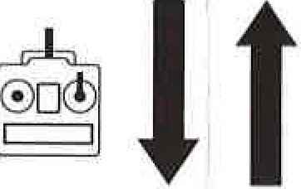
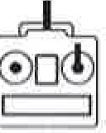

Set item value:
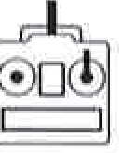
You will now hear tones in loop. Set the value matching to a lone by moving the throttle sUck to the top, when this has been confirmed you can hear the special tone "J> 5-6-5" this means the value has been set and saved. (Keeping the stick at top, you will go back to step 2 and you can select the other items; Moving the stick to bottom within 2 seconds, you will exit the programming mode). The balded texts are the default value.

s | "beep-"  1 short tone | "beep-beep-" 2 short tones | "beep-beep-beep· 3 short tones
Brake | Off | On | --------
Battery type | LI-ion I Li-poly | NiMh / Nied
Cutoff mode | Reduce power | Shut down
Cutoff threshold | Low | Medium | High
Startup mode | Normal | Super soft
Timing | Low | Medium | High
Governor New | Off | On


. 1 -

l

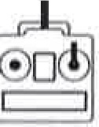
Exit prgramming:
There are 2 ways to exit programming:

- In stop 3, after special lone • J> 5-6-5" , move throttle stick to bottom within 2 seconds.

- In step 2, after "8 short tone", move throttle stick to bottom within 3 seconds.

